MERN and Full Stack Web Development:
Building Modern Web Applications

MongoDB, Express, React, and Node.js

Hamza Latif

Table Of Contents :
Overview of Web Development Basics ---------------------------------------------- Page 1
Purpose of HTML, CSS, and JavaScript ----------------------------------------------------------------- Page 1
Analogy ------------------------------------------------------------------------------------------------------------------ Page 2
How Websites Work ----------------------------------------------------------------------------------------------- Page 3
Setting Up Your Development Environment Using VS Code ----------------------- Page 3
Installing Visual Studio Code --------------------------------------------------------------------------------- Page 4
Creating Your First HTML File -------------------------------------------------------------------------------- Page 4
Installing Extensions ---------------------------------------------------------------------------------------------- Page 4
Understanding VS Code Features -------------------------------------------------------------------------- Page 5
HTML Basic Structure ---------------------------------------------------------------- Page 5
Doctype Declaration ----------------------------------------------------------------------------------------------- Page 6
HTML Tag --------------------------------------------------------------------------------------------------------------- Page 6
Head Tag ---------------------------------------------------------------------------------------------------------------- Page 6
Meta tags --------------------------------------------------------------------------------------------------------------- Page 6
Title Tag ----------------------------------------------------------------------------------------------------------------- Page 7
Body Tag ---------------------------------------------------------------------------------------------------------------- Page 7
Summary --------------------------------------------------------------------------------------------------------------- Page 7
Comments in HTML ------------------------------------------------------------------ Page 8
Understanding HTML Comments -------------------------------------------------------------------------- Page 8
Single and Multiline Comment Examples -------------------------------------------------------------- Page 8
Shortcut Key to Add/Remove Comments -------------------------------------------------------------- Page 8
Linking CSS and JavaScript in HTML ----------------------------------------------- Page 9
Linking CSS ----------------------------------------------------------------------------------------------------------- Page 9
Linking JavaScript ------------------------------------------------------------------------------------------------- Page 9
Element, Tag, Attribute, Attribute Value and Content ------------------------------Page 10
Element ----------------------------------------------------------------------------------------------------------------- Page 10
Opening Tag ---------------------------------------------------------------------------------------------------------- Page 10
Attribute and Attribute Value ---------------------------------------------------------------------------------Page 11
Content ------------------------------------------------------------------------------------------------------------------Page 11
Closing Tag ----------------------------------------------------------------------------------------------------------- Page 11
Headings, paragraphs, and links in HTML ------------------------------------------Page 12
Headings in HTML ------------------------------------------------------------------------------------------------ Page 12
Paragraphs in HTML --------------------------------------------------------------------------------------------- Page 13
Links in HTML ------------------------------------------------------------------------------------------------------- Page 13

Web Development
Overview of Web Development Basics
Purpose of HTML, CSS, and JavaScript:
- HTML (HyperText Markup Language):
- HTML stands for Hypertext Markup Language, and it is the standard markup language used to create web pages.
- HTML allows web developers to define the structure and content of a web page using a series of tags and attributes.
- HTML tags are used to create elements like headings, paragraphs, links, and images, while attributes provide additional information about those elements.
- CSS (Cascading Style Sheets):
- CSS stands for Cascading Style Sheets and is used to add visual style and layout to web pages.
- CSS allows developers to define design, colors, fonts, spacing, and other visual elements of a webpage.
- CSS can be used to create responsive designs that adapt to different screen sizes and devices.
- JavaScript:
- JavaScript is a programming language that is used to add interactivity and functionality to web pages.
- JavaScript acts as the "brain" of the website by enabling front-end scripting and user engagement.
- JavaScript allows developers to create dynamic content that responds to user input or changes in the webpage.

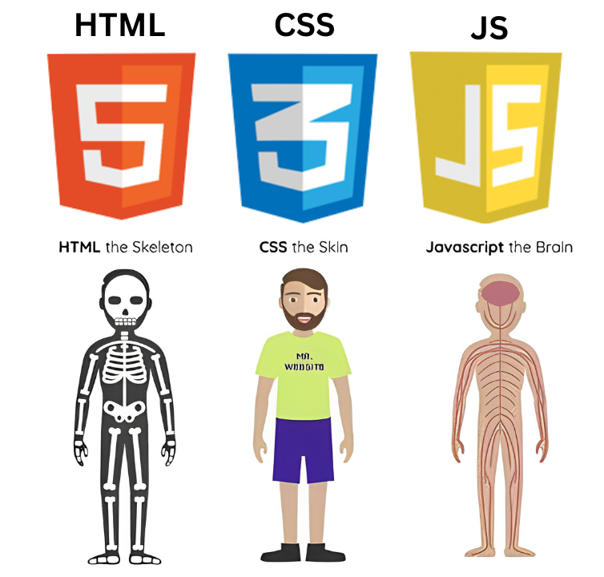

Describing HTML, CSS, and JavaScript Through the Example Of Human Body

Analogy example :
A human body analogy to represent HTML, CSS, and JavaScript :
- HTML (Skeleton): HTML is like the skeleton of a person—it gives the webpage its basic structure.

- CSS (Skin): CSS is like the skin and clothes—it makes the webpage look nice and stylish.

- JavaScript (Brain): JavaScript is like the brain—it makes the webpage smart and interactive, allowing it to do things.

Just like the human body needs all these three to work properly, a webpage needs HTML, CSS, and JavaScript to work properly.

How Websites Work:
- A client (user's browser) sends a request to a web server.
- The server processes this request using backend technologies (e.g., PHP, Python, Node.js etc).
- The server sends back a response composed of HTML, CSS, and JavaScript files, which are rendered in the browser.
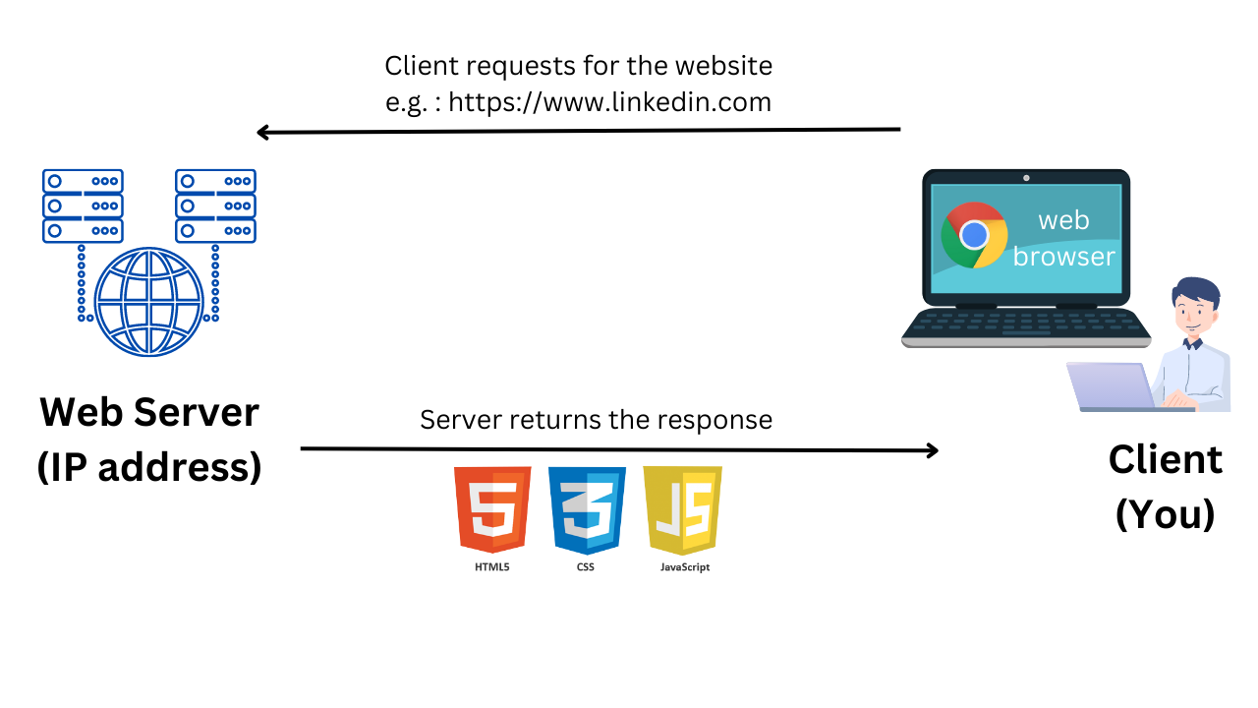

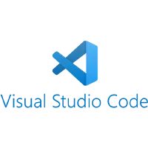
Setting Up Your Development Environment Using Visual Studio Code (VS Code)

Step 1: Installing Visual Studio Code
- What is VS Code?
  - A free, open-source integrated development environment (IDE) by Microsoft designed for multiple programming languages.
  - Offers powerful features like syntax highlighting, extensions, and easy file management.
- Installation:
  - Download and install Visual Studio Code from its official website.
  - Create a folder for your projects.
  - Open this folder in VS Code:
    - Shift + Right-click the folder and choose "Open with Code".
    - If the option isn’t available, restart your computer after installation.
Step 2: Creating Your First HTML File
- File Setup:
  - Create a new file (e.g., index.html) in VS Code.
  - Generates the HTML boilerplate(structure code) by typing an exclamation mark “!” and pressing Enter.
- HTML Structure Code:
<!DOCTYPE html>
<html lang="en">
<head>
<meta charset="UTF-8">
<meta name="viewport" content="width=device-width, initial-scale=1.0">
<title>Document</title>
</head>
<body>

</body>
</html>

Step 3: Installing Extensions
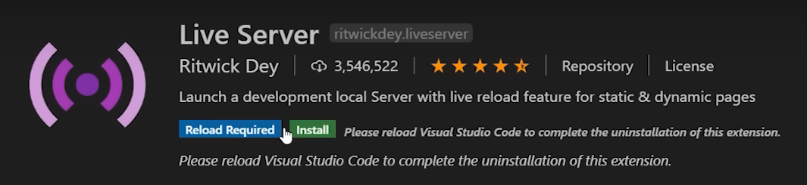

- Live Server Extension:
  - Install from the Extensions tab on the left panel.
  - Refresh VS Code and click Go Live in the bottom-right corner.
  - Benefit: Automatically updates the webpage in your browser with any changes you make to the HTML.

Step 4: Understanding VS Code Features
- Key Panels on the Left Sidebar:
  - Explorer: Manage files in your project.
  - Search: Find specific text in your project.
  - Source Control (Git): Manage version control for your project.
  - Run and Debug: Debug your code.
  - Extensions: Install and manage extensions.
- Settings:
  - User Settings: Applies to all projects.
  - Workspace Settings: Applies only to the current folder/project.
- Pro Tip: Customize keyboard shortcuts to streamline your workflow.

Additional Tips:
- Browser Recommendation: Use Chrome for its developer tools, which are great for debugging and testing.
- Cross-Platform Support: VS Code works seamlessly on macOS and Linux, offering the same features as on Windows.
HTML Basic Structure
<!DOCTYPE html>
<html lang="en">
<head>
<meta charset="UTF-8">
<meta name="viewport" content="width=device-width, initial-scale=1.0">
<title>Document</title>
</head>
<body>

</body>
</html>
- Doctype Declaration:
<!DOCTYPE html>

- Declares the document type and version (HTML5 here). Tells the browser how to render the page.

- HTML Tag:
<html lang="en">

- Root tag of the HTML document. lang="en" specifies the language as English.

- Head Tag:
<head>
<!-- <meta charset="UTF-8">
<meta name="viewport" content="width=device-width, initial-scale=1.0">
<title>Document</title> -->
</head>

- Contains meta-information about the document (not shown on the page directly).Also contain title tag that defines the title of the document.

- Meta tags:
<meta charset="UTF-8">

- Sets the character encoding to UTF-8 (supports most characters from all languages)

<meta name="viewport" content="width=device-width, initial-scale=1.0">

- Makes the page responsive on mobile and other devices by controlling layout and scaling.

- Title Tag:
<title>Document</title>

- Sets the title of the web page (shown in browser tab).

- Body Tag:
<body>

</body>

- Contains the visible content of the web page (text, images, links, etc.).

Summary:
This is a basic HTML5 template with structure ready to add content. The head section is for setup and settings; the body is where you put your webpage content.

Comments in HTML
Understanding HTML Comments:
HTML comments are used to insert notes, explanations, or temporarily hide parts of the code. They do not appear on the web page and are only visible in the HTML source code.
Here is the syntax of comment in HTML:

<!-- This is a comment -->

Example:
<!-- Main heading of the page -->
<h1>Welcome to My Website</h1>

<!-- <p>This paragraph is hidden for now.</p> -->

Multiline Comment Example:
<!--
This is a multiline comment.
It spans more than one line.
-->

Shortcut Key to Add/Remove Comments:
Platform | Shortcut
Windows/Linux | Ctrl + /
Mac | Cmd + /
➡️ Use this shortcut in most code editors like VS Code, Sublime Text, and Atom.

Linking CSS and JavaScript in HTML
Linking CSS:
To style an HTML webpage, you can link a CSS (Cascading Style Sheets) file using the <link> tag inside the <head> section of your HTML document. This tells the browser where to find the stylesheet and apply its styles to the HTML elements.
Example:
Html:
<head>
<link rel="stylesheet" href="style.css">
</head>

Here, styles.css is the external CSS file that contains your CSS codes. Linking CSS helps keep your code organized by separating structure (HTML) from design (CSS).
Linking JavaScript:
To add interactivity to your webpage, you can link a JavaScript file using the <script> tag. This is usually done before the closing </body> tag so the HTML loads first.
Example:
Html:
<body>
<!-- HTML content here -->

<script src="script.js"></script>
</body>

Here, script.js is an external JavaScript file. Linking JavaScript externally helps keep your code clean, maintainable, and organized by separating behavior (JavaScript) from structure (HTML).

Element, Tag, Attribute, Attribute Value and Content
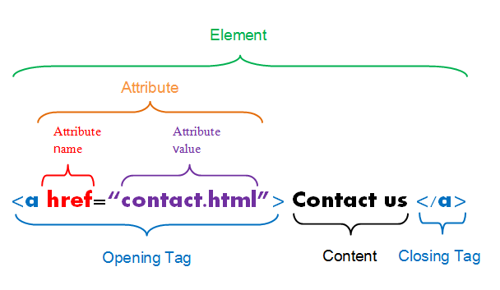

Element:
In HTML, everything you create — like links, images, paragraphs — is built using elements.
An element is made of several parts:
- Opening Tag:
  - This tells the browser what kind of thing you are creating.
  - Enclosed in angle brackets (< >)
Example:
<a>

- Attribute and Attribute Value (inside the opening tag):
  - Attributes give extra information about the element.
  - They follow the format: name="value".
Example:
href="contact.html"

- Here:
  - href is the attribute name.
  - "contact.html" is the attribute value, placed inside quotes(“”).

- Content (between the tags):
  - This is what the user sees on the webpage.
Example:
Contact us

- Closing Tag:
  - This tells the browser that the element is finished.
  - It looks like the opening tag but has a “/ ” inside.
Example:
</a>

So the full element looks like:
<a href="contact.html">Contact us</a>

- <a href="contact.html"> → Opening Tag (with attribute)
- Contact us → Content
- </a> → Closing Tag
- Everything together → Element
In short:
An element = Opening tag + Attributes + Content + Closing tag.

Headings, paragraphs, and links in HTML
1. Headings in HTML
Headings define the structure and hierarchy of content on a webpage. HTML supports six levels of headings, from <h1> (most important) to <h6> (least important).
Example:
<h1>This is a Heading 1</h1>
<h2>This is a Heading 2</h2>
<h3>This is a Heading 3</h3>
<h4>This is a Heading 4</h4>
<h5>This is a Heading 5</h5>
<h6>This is a Heading 6</h6>

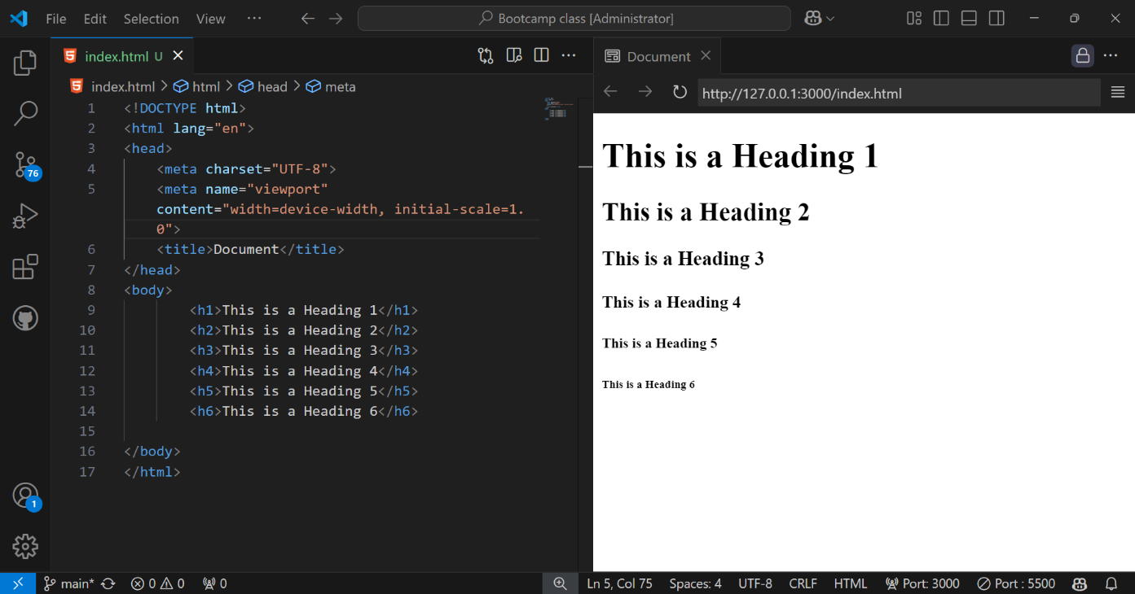
Output:

2. Paragraphs in HTML
Paragraphs are defined using the <p> tag and are used to group blocks of text.
Example:
<p>This is a paragraph of text.</p>

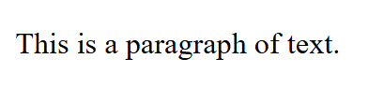
Output:

3. Links in HTML
Links are created using the <a> (anchor) tag. The href attribute defines the destination URL.
Example:
<a href="https://www.google.com">Visit Google</a>
or
<a href="https://www.google.com" target="_blank">Visit Google</a>

- target="_blank" opens the link in a new tab.
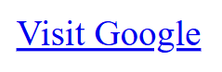
Output:

Images in HTML
Image Tag:
Images are inserted using the <img> tag. It’s a self-closing tag and requires the “src” and “alt” attributes.
Syntax:
<img src="image.jpg" alt="Description of image">

Example:
<img src="Nature.jpg" alt="Nature Image">

- src = Source URL or path of the image

- alt = Alternate text (for screen readers and broken images)
Output:

Alternate text shows when image doesn’t load or is corrupted.

Output:

